Chapter 2 Assignment

2.2: The least number of bits needed to give each character of the English alphabet a unique bit pattern would be 5 bits. For upper-case and lowercase versions, you would need 6 bits.

2.10:

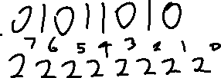

2.11:

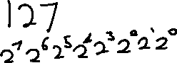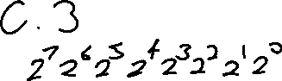

2.46:

